**Input using TextEdit**

1. Make similar layout with unique id’s of TextEdit and Button .

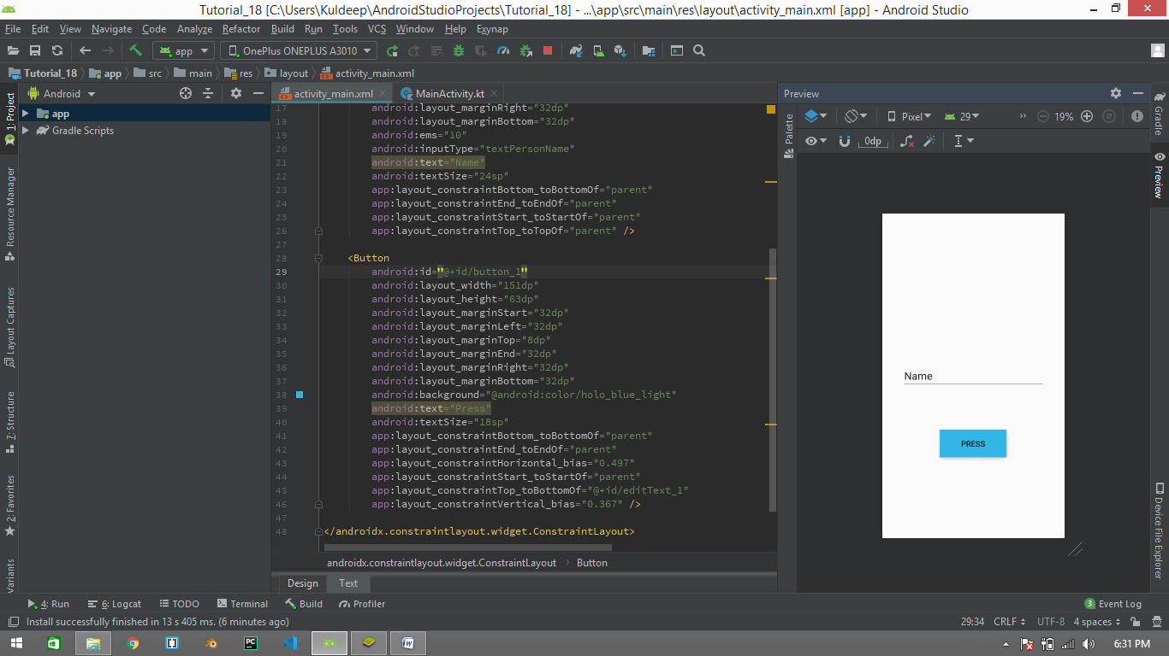

1. Follow the below code , to simply create the object and use it to the make a toaster and print textedit value

var button1:Button= findViewById(R.id.*button_1*)  
var text_view:EditText = findViewById(R.id.*editText_1*)  
  
button1.setOnClickListener **{** Toast.makeText(this,"Hello "+ text_view.*text*,Toast.*LENGTH_LONG*).show()  
**}**

1. Run your **Resource File.**

